Lab 4
Simple SELECT Queries

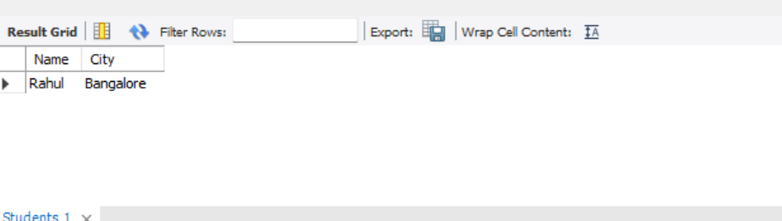

The SELECT command is used to retrieve specific columns from a table. Here, the Name and City columns are displayed for the student Rahul from the Students table.
Result: Thus, the name and city of the student Rahul were successfully retrieved.

